Mockito Hands-On Exercises

Exercise 1: Mocking and Stubbing
Scenario:
You need to test a service that depends on an external API. Use Mockito to mock the external API and stub its methods.

Steps:
First create a pom.xml file like this;

<project xmlns="http://maven.apache.org/POM/4.0.0"
xmlns:xsi="http://www.w3.org/2001/XMLSchema-instance"
xsi:schemaLocation="http://maven.apache.org/POM/4.0.0
http://maven.apache.org/xsd/maven-4.0.0.xsd">
<modelVersion>4.0.0</modelVersion>
<groupId>com.example</groupId>
<artifactId>mockito-test</artifactId>
<version>1.0-SNAPSHOT</version>
<properties>
<maven.compiler.source>1.8</maven.compiler.source>
<maven.compiler.target>1.8</maven.compiler.target>
</properties>
<dependencies>
<dependency>
<groupId>org.mockito</groupId>
<artifactId>mockito-core</artifactId>
<version>4.0.0</version>
<scope>test</scope>
</dependency>
<dependency>
<groupId>org.junit.jupiter</groupId>
<artifactId>junit-jupiter</artifactId>
<version>5.8.2</version>
<scope>test</scope>
</dependency>
</dependencies>
<build>
<plugins>
<plugin>
<groupId>org.apache.maven.plugins</groupId>
<artifactId>maven-surefire-plugin</artifactId>
<version>2.22.2</version>
</plugin>
</plugins>
</build>
</project>

Then create a class called External Api.java
package com.example;
public interface ExternalApi {
String getData();
}
MyService.java
package com.example;
public class MyService {
private ExternalApi externalApi;
public MyService(ExternalApi externalApi) {
this.externalApi = externalApi;
}
public String fetchData() {
return externalApi.getData();
}
}
MyServiceTest.java
package com.example;
import org.junit.jupiter.api.Test;
import static org.mockito.Mockito.*;
import static org.junit.jupiter.api.Assertions.*;
public class MyServiceTest {
@Test
public void testExternalApi() {
ExternalApi mockApi = mock(ExternalApi.class);
when(mockApi.getData()).thenReturn("Mock Data");
MyService service = new MyService(mockApi);
String result = service.fetchData();
System.out.println("testExternalApi output: " + result); assertEquals("Mock Data", result);
}
@Test
public void testVerifyInteraction() {
ExternalApi mockApi = mock(ExternalApi.class);
MyService service = new MyService(mockApi);
service.fetchData();
verify(mockApi).getData();
System.out.println(" testVerifyInteraction: getData() was called");
}
}
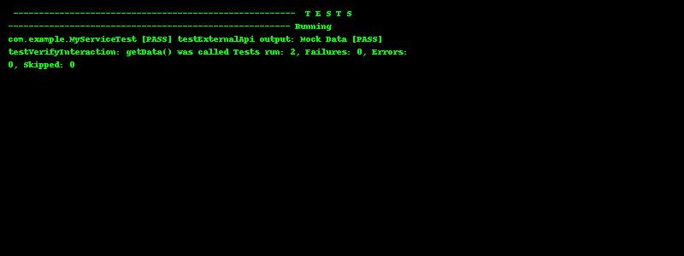

Exercise 2: Verifying Interactions
Scenario:
You need to ensure that a method is called with specific arguments.
Pom.xml file:
<project xmlns="http://maven.apache.org/POM/4.0.0"
xmlns:xsi="http://www.w3.org/2001/XMLSchema-instance"
xsi:schemaLocation="http://maven.apache.org/POM/4.0.0
http://maven.apache.org/xsd/maven-4.0.0.xsd">
<modelVersion>4.0.0</modelVersion>
<groupId>com.example</groupId>
<artifactId>mockito-test</artifactId>
<version>1.0-SNAPSHOT</version>
<properties>
<maven.compiler.source>1.8</maven.compiler.source>
<maven.compiler.target>1.8</maven.compiler.target>
</properties>
<dependencies>
<!-- JUnit 5 -->
<dependency>
<groupId>org.junit.jupiter</groupId>
<artifactId>junit-jupiter</artifactId>
<version>5.8.2</version>
<scope>test</scope>
</dependency>
<!-- Mockito -->
<dependency>
<groupId>org.mockito</groupId>
<artifactId>mockito-core</artifactId>
<version>4.0.0</version>
<scope>test</scope>
</dependency>
</dependencies>
<build>
<plugins>
<plugin>
<groupId>org.apache.maven.plugins</groupId>
<artifactId>maven-surefire-plugin</artifactId>
<version>2.22.2</version>
</plugin>
</plugins>
</build>
</project>
Then ExternalApi.java file:
package com.example;
public interface ExternalApi {
String getData();
}
MyService.java
package com.example;
public class MyService {
private ExternalApi externalApi;
public MyService(ExternalApi externalApi) {
this.externalApi = externalApi;
}
public String fetchData() {
return externalApi.getData();
}
}
MyServiceTest.java
package com.example;
import org.junit.jupiter.api.Test;
import static org.mockito.Mockito.*;
import static org.junit.jupiter.api.Assertions.*;
public class MyServiceTest {
@Test
public void testVerifyInteraction() {
ExternalApi mockApi = mock(ExternalApi.class);
when(mockApi.getData()).thenReturn("Mock Data");
MyService service = new MyService(mockApi);
service.fetchData();
verify(mockApi).getData();
System.out.println("[PASS] testVerifyInteraction: getData() was called");
}
}
Output:

